# Pre-k Math: Classification

Classification is the skill of sorting or grouping items by similar characteristics, such as colors, shapes, or sizes. Children naturally classify toys by type and sort crayons by color. Children between the ages of 3 and 4 years old enjoy sorting and classifying objects usually by one characteristic (color, shape, or size). If preschoolers do not know the names of colors or shapes, it may be helpful to ask them to find something that is the same color or shape as a specific item. As children develop, they can classify by more than one characteristic, such as sorting the green square blocks.

Preschoolers benefit from exploring a variety of materials and making discoveries. When selecting materials for young children, avoid any small items that could pose a choking hazard. As children explore a bin of rocks and leaves, they can learn which items are big, little, rough, smooth, thick, thin, hard, soft, wet, or dry. Children are learning to classify items by similarities and differences.

# How to teach children?

1. Patterns with bear

Counting Bears are a great math manipulative to use with preschoolers. You can sort, count, or use them with patterns. I created some pattern cards to help with this. The first page is an AB pattern, meaning two colors alternate in the pattern. The second page is an ABC pattern, meaning three are three colors in the pattern. For this activity, your preschooler will set the colored bear on top of the matching color to create a pattern. On the ABC pattern cards, the last circle is left empty. That is for your child to tell you what color it should be.

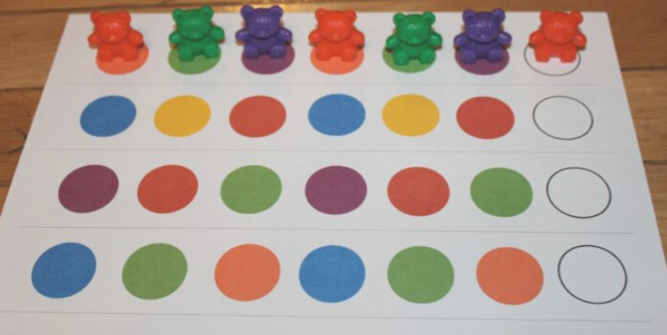

1. Sorting Color with Bears

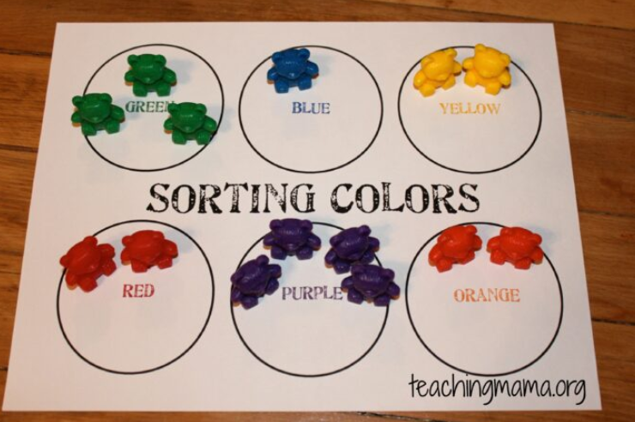

1. Graphing

Graphing is always good to introduce to preschoolers. It doesn’t have to be complex, but you can do a simple activity like graphing the types of transportation on a bar graph and use small pictures or toys (or I used erasers from The Dollar Tree).

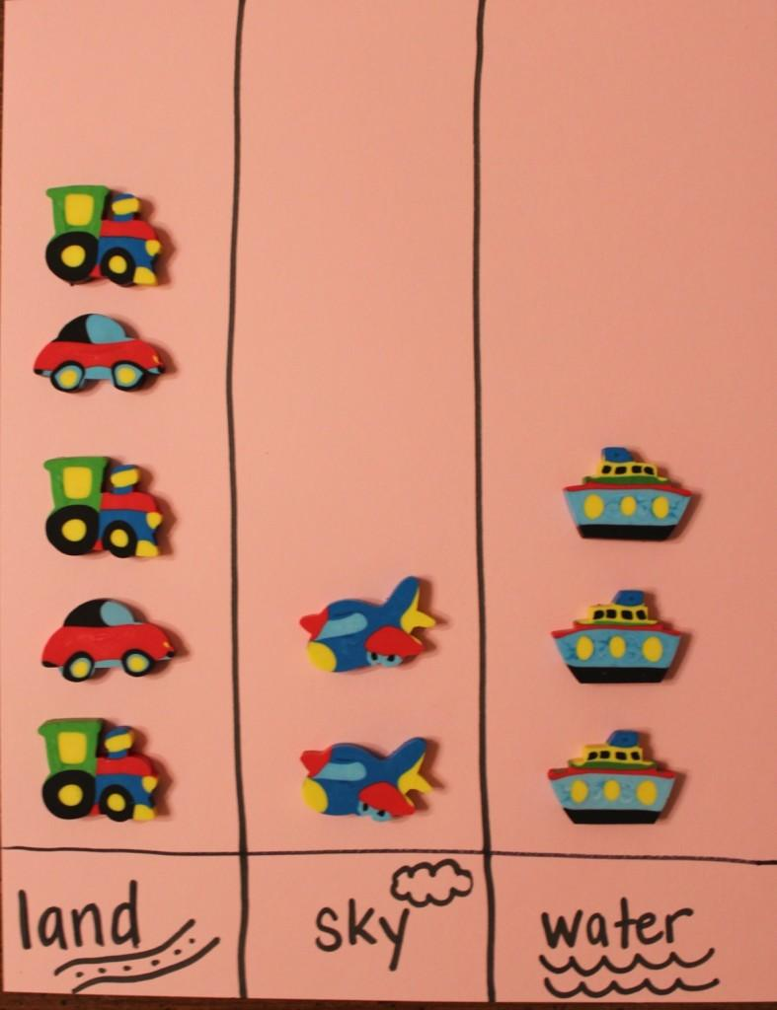

1. Shape Wheel

This is a fun activity for learning shapes! Just print this shape wheel and draw the same colored shapes onto clothespins. Have your child match the clothespin to the shape on the wheel. This is great for working on fine motor skills!

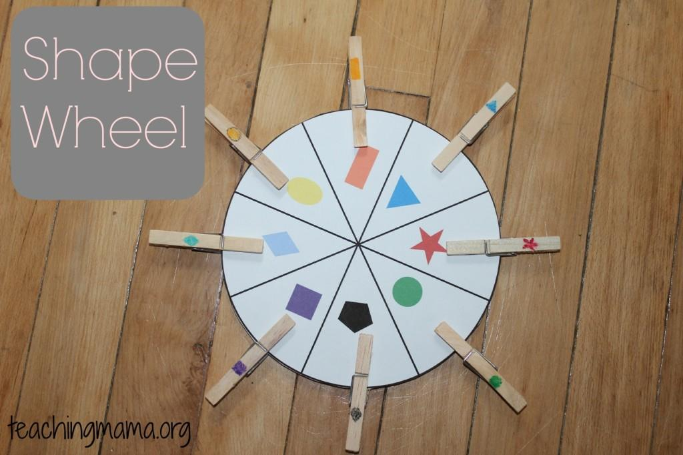

1. Dice Game

This is a really fun game! I took this Melissa & Doug wooden toy and put white circle stickers on the top of the pegs. I wrote numbers 1-6 and had 2 stars. I had my son roll the dice and whatever number it landed on, he would pound with a toy hammer. If the number he rolled was already down, he hit the star. Not only was this fun for him, but he was able to “subitize”, which simply means to recognize numbers instantly without counting the dots.

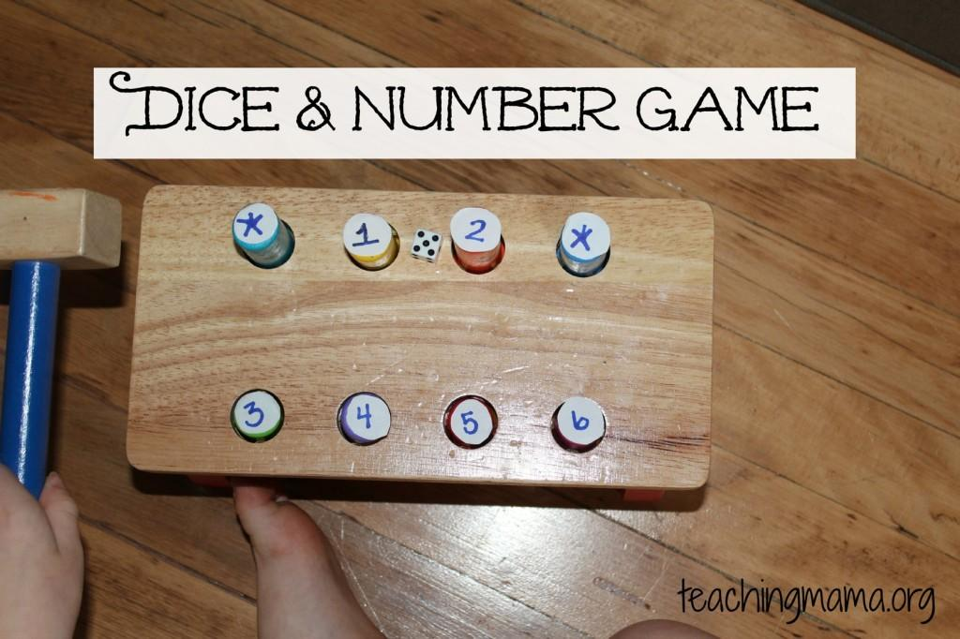

1. Balloons

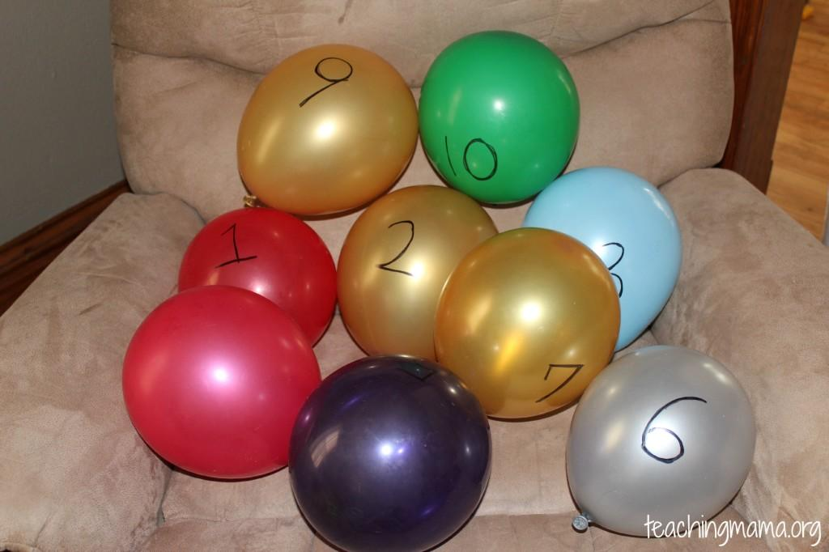

1. Estimating with water

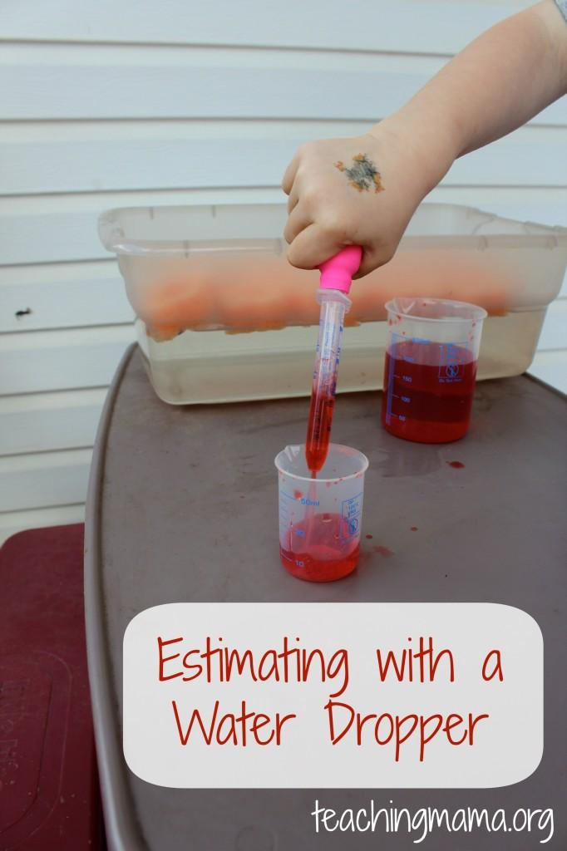

1. Pouring and Comparing

We practiced pouring skills with rice into these beakers. Then I had my son line them up from biggest to smallest. Using comparative words like big/small or empty/full helps teach preschoolers about simple concepts of measurement. This is simple and you could elaborate on this activity.

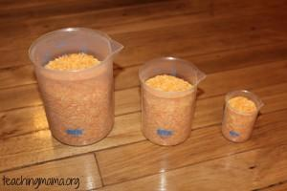

One more easy way to practice measurement is with Unifix cubes. Place different lengths of tape on the floor or poster board. Then have your child use Unifix cubes to measure the lines. This is a simple way to practice counting, measuring, and comparing lengths.

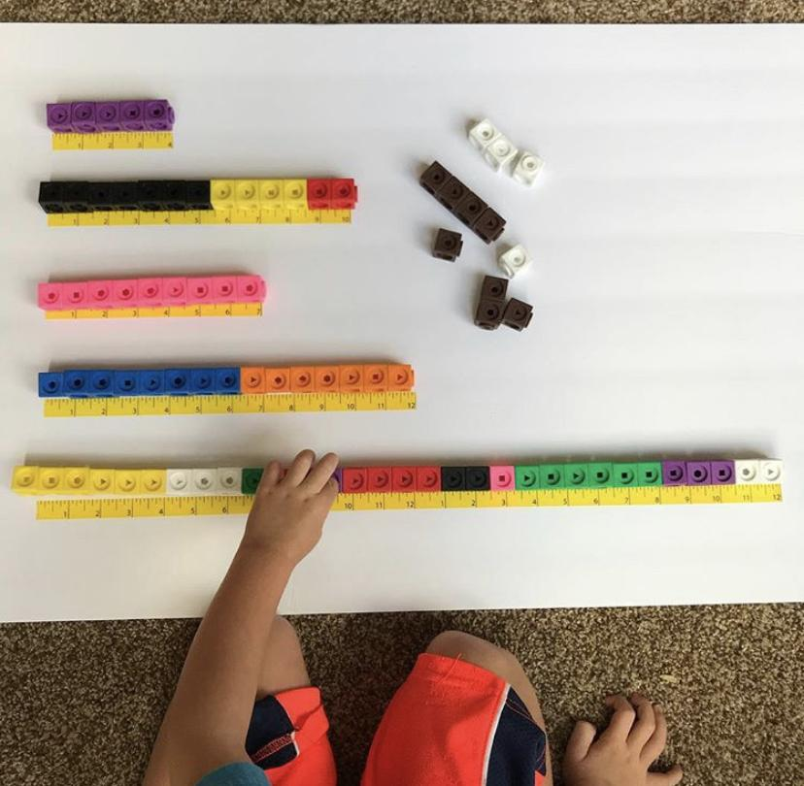

Video Reference Vid1: <https://youtu.be/qIE-kjdeNnY>

Vid2: <https://youtu.be/O3g12WeHUp0>